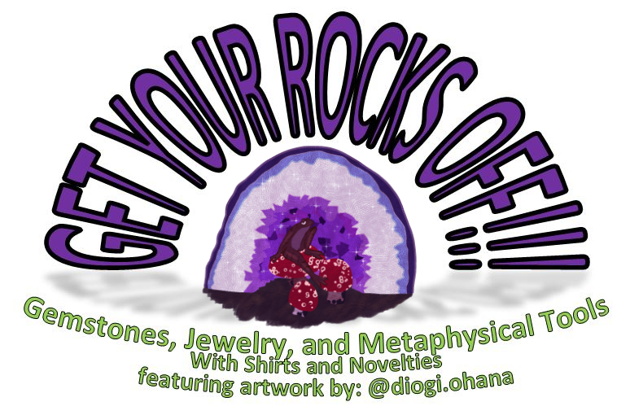
Azezuite: Rosophia, Quartz (Smokey), Labradorite, and Onyx
Earring and Bracelet Set
$25

www.getyourrocksoff.shop
@getyourrocksoffshop
Turquoise, Magnesite, and Quartz Earrings
$12

www.getyourrocksoff.shop
@getyourrocksoffshop
Azezuite: Rosophia, Hematite, Agate, and Quartz (Smokey) Earrings
$12

www.getyourrocksoff.shop
@getyourrocksoffshop
Jasper (Brecciated), Onyx, and Garnet Anklet
$16

www.getyourrocksoff.shop
@getyourrocksoffshop
Onyx and Tiger’s Eye Earrings
$12

www.getyourrocksoff.shop
@getyourrocksoffshop
Quartz (Aura) and Jasper (Blue) Earrings
$12

www.getyourrocksoff.shop
@getyourrocksoffshop

Quartz (Aura)
- “Master healer” – Can be used for any Condition
- Activates all chakras
- Energy ascension
- Activates body’s natural healing mechanism
Jasper (Blue)
- “Supreme Nurturer”
- Connects to the spiritual world
- Balances yin-yang energies and stabilizes the aura

Onyx
- Strength giving
- Provides support in difficult or confusing circumstances and times of enormous mental or physical stress
Tiger’s Eye
- Well-grounded and a high-vibrational state; draws spiritual energies to earth
- Protective against ill wishing and curses
- Treats eyes and aids night vision

Azezulite: Rosophia
- Grounds spiritual energy with profound earth connection
- Strengthens rational and analytic thought
- Facilitates assessing what is spiritual truth and what is illusion
Quartz (Smokey)
- Most efficient grounding and anchoring stone
- Raises vibration during meditation
- Protective stone with strong link to earth and root chakra
Labradorite
- “Light Bringer”
- Highly mystical and protective stone
- Raises consciousness and connects with universal energies
- Deflects unwanted energies and prevents energy leakage
Onyx
- Strength giving
- Provides support in difficult or confusing circumstances and times of enormous mental or physical stress

Turquoise
- Efficient healer for solace of spirit and well-being of body
- Protective
- Spiritual attunement
- Enhances communication with physical and spiritual worlds
- Strengthens meridians
- Enhances physical and psychic immune systems
- (Tibetan Turquoise) Clears suppressed self-expression
- Chakra Point – Throat and Third Eye
Magnesite
- Deep peace to meditation and relaxation
- Enhances visualization and imagery
- Unconditional love, including self-love and love for difficult people due to behavior or addiction
- Calming effect to emotions, promoting tolerance for emotional stress
- Chakra Point – Throat and Heart
Quartz
- “Master Healer” – Can be used for any condition
- Most powerful healing and energy amplifier
- Raises energy to highest possible level
Azezulite: Rosophia
- Grounds spiritual energy with profound earth connection
- Strengthens rational and analytic thought
- Facilitates assessing what is spiritual truth and what is illusion
Hematite
- Grounding and protecting
- Harmonizes mind, body, and spirit
- Dissolves negativity and prevents negative energies entering the aura
- Boosts self-esteem and confidence
Agate
- Very stable and grounding
- Brings emotional, physical, and intellectual balance
- Harmonizes yin and yang
Quartz (Smokey)
- Most efficient grounding and anchoring stone
- Raises vibration during meditation
- Protective stone with strong link to earth and root chakra

Jasper (Brecciated)
- “Supreme Nurturer”
- Grounding and emotional stability
- Draws excess energy away from the head, promoting mental clarity
Onyx
- Strength giving
- Provides support in difficult or confusing circumstances and times of enormous mental or physical stress
Garnet
- Energizing and regenerating
- Cleanses and reenergizes chakras
- Revitalizes, purifies, and balances energy
- Removes inhibitions
- Regenerates body and stimulates metabolism

